Race of Doom Group 6

Design Document

Advisor: Subin Mao

Team Members:

Aaron Gienger – Embedded Hardware Programing

Andy Nguyen – Electrical Hardware Design and Integration

Ben Dubin – Software Development

Blake Carlson – Embedded Hardware Programing

Carson Tow – Security Programing and Team Representative

Team Email: [sdmay24-06@iastate.edu](mailto:sdmay24-06@iastate.edu)

Team Website: <https://sdmay24-06.sd.ece.iastate.edu>

Revised: 12/3/2023 Version 2.2

Executive Summary

Development Standards & Practices Used

5.11.5 Fault protection

6.2 Size and weight

6.13.4 Materials and design

Summary of Requirements

* Design an autonomous vehicle that can go around a track.
* Make it durable enough to resist hacking attempts on a track.
* Needs to be manually controllable in some capacity.
* Must be the same size as a typical RC car.
* RC car must be able to detect and avoid obstacles.
* Manage the workflow effectively between teammates, advisors, and the client.

Applicable Courses from Iowa State University Curriculum

CprE 288

EE 201

SE 329

New Skills/Knowledge acquired that was not taught in courses.

Setting up and coding on an Arduino:

1. Wiring up the ultrasonic and IR sensors
2. Developing C++ code to fulfill the requirements of autonomy for the vehicle
3. Setting up communication to RC components

Table of Contents

1 Team 4

1.1 Team Members 4

1.2 Required Skill Sets for Your Project 4

1.3 Skill Sets covered by the Team 4

1.4 Project Management Style Adopted by the team 4

1.5 Initial Project Management Roles 4

2 Introduction 5

2.1 Problem Statement 5

2.2 Requirements & Constraints 5

2.3 Engineering Standards 5

2.4 Intended Users and Uses 5

3 Project Plan 6

3.1 Task Decomposition 6

3.2 Project Management/Tracking Procedures 7

3.3 Project Proposed Milestones, Metrics, and Evaluation Criteria 7

3.4 Project Timeline/Schedule 7

3.5 Risks And Risk Management/Mitigation 8

3.6 Personnel Effort Requirements 8

3.7 Other Resource Requirements 8

4 Design 9

4.1 Design Content 9

4.2 Design Complexity 9

4.3 Modern Engineering Tools 9

4.4 Design Context 9

4.5 Prior Work/Solutions 10

Design Decisions 11

Proposed Design 11

4.7.1 Design 0 (Initial Design) 11

Design Visual and Description 11

Functionality 12

4.7.2 Design 1 (Design Iteration) 13

Design Visual and Description 13

4.8 Technology Considerations 14

4.9 Design Analysis 14

5 Testing 15

5.1 Unit Testing 15

5.2 Interface Testing 15

5.3 Integration Testing 15

5.4 System Testing 15

5.5 Regression Testing 16

5.6 Acceptance Testing 16

5.7 Security Testing (if applicable) 16

Testing Results 16

6 Implementation 16

7 Professionalism 17

7.1 Areas of Responsibility 17

7.2 Project Specific Professional Responsibility Areas 17

8 Closing Material 18

8.1 Discussion 18

8.2 Conclusion 18

8.3 References 19

8.4.1 Team Contract 19

List of figures/tables/symbols/definitions

* Figure 3.1 – Task Decomposition Flow chart
* Figure 3.2 – Gannt Chat for task to complete from Aug. 23 to May 24
* Figure 3.3 – Table outlining effort requirements.
* Figure 4.1 – Table outlining the design in respect to different contexts.
* Figure 7.1 – Table outlining factors of engineering responsibility.

# Team

* 1. Team Members

Ben Dubin

Andy Nguyen

Blake Carlson

Carson Tow

Aaron Gienger

* 1. Required Skill Sets for Your Project

Embedded hardware Programming

Electrical hardware design

Hardware and sensor tampering protections

Programming for remote control hardware

Software development

Basic electrical work & soldering

* 1. Skill Sets covered by the Team

Embedded hardware Programming (Blake Carlson, Aaron Geinger)

Electrical hardware design (Andy Nguyen)

Programming for remote control hardware (Carson Tow)

Software development (Ben Dubin)

Basic electrical work & soldering (Everyone)

* 1. Project Management Style Adopted by the team

Agile

* 1. Initial Project Management Roles

Carson Tow – Team Representative

Andy Nguyen – Event Coordinator/Manager

# Introduction

## 2.1 Problem Statement

Build a small remote-controlled car that can operate autonomously. The car should navigate through an outdoor track and avoid being “hacked” by any potential traps set by the track team or otherwise malfunctioning.

The vehicle should be built to be durable and protected enough to successfully complete the race. If possible, the vehicle should try to complete the race in a timely manner and win against the other team’s vehicle.

## 2.2 Requirements & Constraints

All the constraints and requirements for this project are and will continuously be set out by the 3 project teams in conjunction with the university professor acting as the client. There are already several constraints and requirements set by the teams and they will continue to increase in quantity. Some technical requirements include:

* Cars will be approximately 1/10th Scale
* Vehicles will use agreed upon sensors/sensory methods
* Vehicles will be able to operate autonomousl**y**
* Vehicles must overcome unspecified obstacles/traps devised by our track team

We also are limited by some non-technical constraints such as:

* Vehicles with use the allowed budget for cars and components
* Approval of new orders before being purchased
* Communication and Approval of parts, size, other design choices with additional vehicle and track teams
* Must be completed in the given 2 semester time frame for Senior Design

## 2.3 Engineering Standards

5.11.5 Fault protection:

Because the vehicles will be used in different/unique uses and environments. This standard is important for the safety of the components of the vehicle. For example, protection in the case of a short circuit.

6.2 Size and weight:

This standard will be important in the scope of this project as we are designing the vehicles in conjunction with the team designing the track as well as the other vehicle’s team. Without this standard a team could make another’s design obsolete because they scaled either their track or vehicle too large or small.

6.13.4 Materials and design:

For this project the materials and ground up design are important aspects of the project. Specifically what materials and components will be important to use standards.

## 2.4 Intended Users and Uses

One possible use for this project going forward is to implement it (perhaps on a different scale or specific design) for a final project in an engineering course. A class could use the code as a base and build the vehicle to go with or use the vehicle/track design and fill in missing program components to make a successful and operational remote-control vehicle.

# Project Plan

## 3.1 Task Decomposition

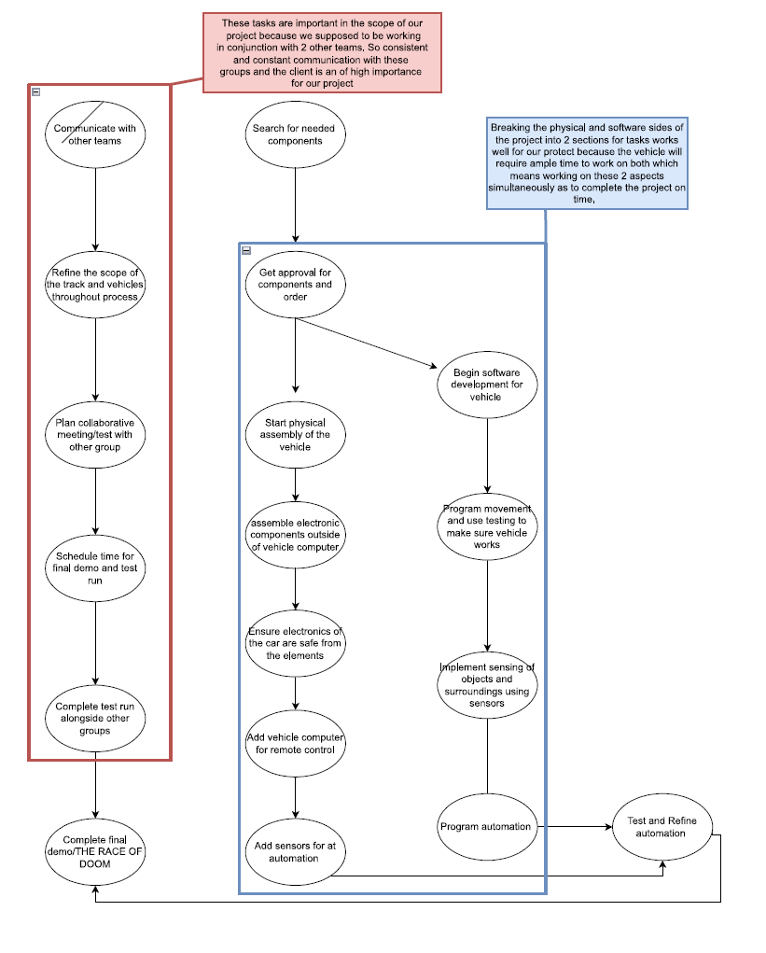

Figure 3.1 – Task Decomposition Flow chart

## 3.2 Project Management/Tracking Procedures

We plan on using an agile project management style with weekly team meetings and roles that coincide with the scrum system. We are using discord to host our online meetings and GitHub to house our repository. We will create tasks on GitHub and use its features to help track our progress and keep us aware of our deadlines.

## 3.3 Project Proposed Milestones, Metrics, and Evaluation Criteria

As the project develops, these metrics/milestones may be changed/tweaked:

- Vehicle remains operational when colliding with objects at speeds of around 20mph

- Vehicle will be able to detect and avoid 80% of objects on field

- Scanners will recognize and detect objects every 10ms

- Vehicle will not cross any boundary lines at any point during the race

- Core function of components (sensors, motor functions) remains operational in the case of interference from other teams (via hacking)

- Vehicle can complete 1 lap at any speed on a predetermined track

## 3.4 Project Timeline/Schedule

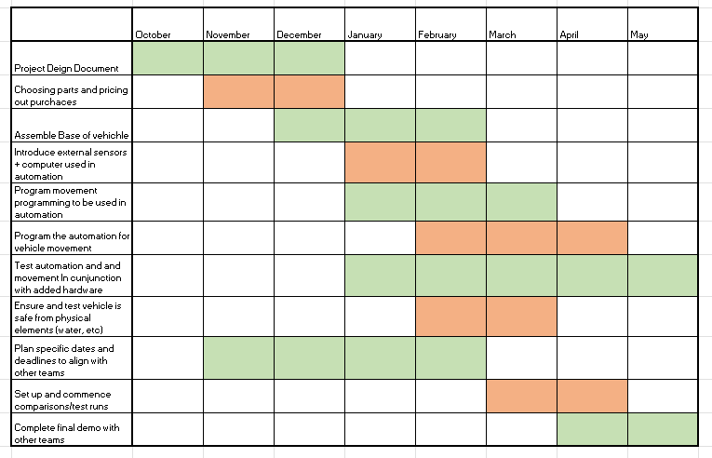

Figure 3.2 – Gannt Chat for task to complete from Aug. 23 to May 24

## 3.5 Risks And Risk Management/Mitigation

Searching for components: Components work as expected, also finding the correct parts(availability) .25

Software development/Automation: Code not working as intended .2

Communication between computer and vehicle: connection errors, track hacking .3

Building and Assembly of vehicle: Components breaking/failing .5

To eliminate the risks with components breaking or failing would be making sure they are good products and built well, as well as having backups for potential replacement parts. Some of the other risks come with the coding side and we can eliminate those by running tests over the code many times for every potential situation that the vehicle may encounter.

## 3.6 Personnel Effort Requirements

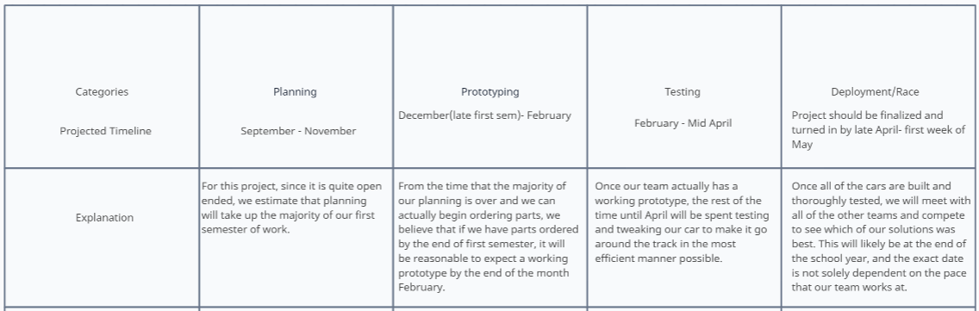

Figure 3.3 – Table outlining effort requirements

## 3.7 Other Resource Requirements

As far as ordering additional resources, since our project is school sponsored, we will have to do our research, and go to the TLA to place orders on the items we need. The track team may have a little bit of a different budget and resource requirement, so the other teams may have to take that into account when it comes to setting and working with any additional funds we may have.

# 4 Design

## 4.1 Design Content

This project revolves around modifying an RC car platform to drive autonomously around a preset track with obstacles designed by another senior design team. Our vehicle will compete in a time trial against solutions from other teams.

### 4.2 Design Complexity

1. Our project involves multiple component parts that are needed for the functionality of our vehicle. Sensors are needed for the navigation of the robot, the information gathered from the sensors will feed into a microcontroller which will then control the motors to perform the desired action. These components will need to be powered by some voltage source, such as a battery.
2. Our project involves a wide range of issues with no obvious solutions. Our track team is constrained by set rules; however, we do not know the full scope of what they will make and how it will affect our car. Therefore, our vehicle must have multiple functionalities and components that will help it prepare for a variety of scenarios

### 4.3 Modern Engineering Tools

* Git-Hub – Version Control
* Visual Studio Code – Programming and Designing
* Microsoft suite including – Documentation for design and processes of design
  + Excel
  + OneDrive
  + PowerPoint
* Voltmeter – Measuring voltage
* Soldering Iron – Hardware assembly

## 

## 

## 4.4 Design Context

|  |  |  |
| --- | --- | --- |
| **Area** | **Description** | **Examples** |
| Public health, safety, and welfare | Our project by nature does not really affect the wellbeing of others. Since it is a competition to see which team’s small autonomous car can get around a track faster, it should not have any health/safety related implications. | None should be no real safety concerns. |
| Global, cultural, and social | Since our project does not have any real cultural implications, we must create an original solution and avoid violating any ethical standards. | Development or operation of the solution would violate a profession’s code of ethics, implementation of the solution would require an undesired change in community practices |
| Environmental | We are choosing to go with a battery powered vehicle rather than a gas powered one in the interest of environmental sustainability and ease of use. | We are moving towards a future with self-driving, electric vehicles at the forefront, and we hope to simulate that. |
| Economic | Our project is constrained by cost due to the budget restrictions our client has imposed upon us. | One example of why this cost restriction has been applied is the potential use case of our project in a classroom for other students to assemble. Therefore, we have to be cost conscious when designing our solution. |

Figure 4.1 – Table outlining the design in respect to different contexts.

### 4.5 Prior Work/Solutions

We will be taking some elements that we have learned from our previous classes; this includes CPRE 288 and EE201. In CPRE 288 we focused on developing embedded software that was used to interpret data from different types of sensors that are similar to the ones that we will be using in this project. Another skill that will be useful is the circuit designs that we learned from EE201. During the wiring process we will be using a breadboard to connect our system together.

There are recent projects that have been done for autonomous cars that include using a LiDAR sensor (Gong). A LiDAR sensor has a lot of benefits for precision and accuracy in the reading for the data. But since it is not in our budget, we will use ultrasound sensors. So, the advantage is that we will be able to make our design on a tighter budget, but we sacrifice some performance in the speed and versatility of our vehicle.

## Design Decisions

1. The RC car will be built on a 1/10 scale model to match the tracks' needs as well as to stay consistent with the other team. We will be using a functional RC car kit that will include all of the basic RC vehicle functionalities.
2. One aspect of our vehicle includes having a vehicle that will stay within the borders of the track. We plan on doing this by having 2 IR sensors (one on each side) to detect the marking of the borders of the track.
3. For object detection we will be using a series of ultrasound sensors that will collect data from the front of the vehicle to pick up any objects or walls on the track.

## Proposed Design

### 4.7.1 Design 0 (Initial Design)

### Design Visual and Description

The Physical design of our project will be a “Hobby Level” Remote control Car with durable, multi-surface rubber wheels, a basic plastic frame and transparent plastic outer shell, and Standard RC batteries, remote, and other on-board electronics. In addition to the RC base, we will include an Arduino to control the on-board electronics based on input from several Infra-red and ultra-sonic sensors that will also be included in the on-board electronics.

The Components of the Vehicle and their functionalities are as follows:

* Wheels/Car Body
  + - The larger and more durable wheel and body choice will allow the car to operate outdoors on rough terrain, on bumpy cement, etc. Which ensures that the vehicle will not be hindered by physical constrains on the ground.
* Arduino
  + - The on-board Arduino (along with a breadboard) will act as the brain of the vehicle and will connect to all the sensors as well as motors to automate the vehicle's navigation. It also will have software written to prevent the various aspects of the design from being compromised by the hacking performed by the track team.
* Sensors (IR and US)
  + - The various sensors on the vehicle will take in data about its surroundings to determine how to navigate the track.
* Remote Control
  + - The remote control will be operated during the Race to control the speed of the vehicle to help navigate its way through obstacles.

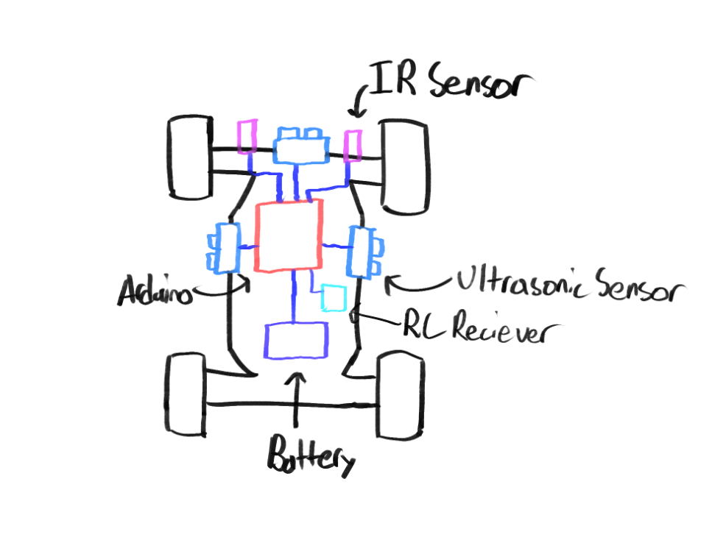

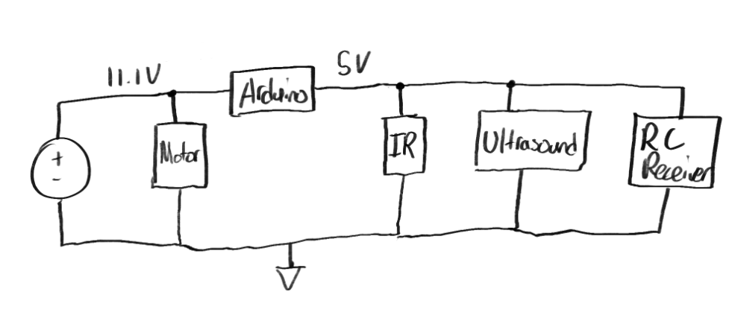

### Functionality

Our Design is to implement in a race against another team designing a car to similar specifications, and through a track designed by a team whose goal is to hinder the vehicles. This design is a versatile approach with a focus on using the sensors to keep our car centered on the track no matter what the constrictions are. This should be able to detect objects in front of the vehicle as well as the walls to the side (if any). With this implementation we will have enough voltage to power all of the components without running into any issues. The overall design will fulfill the basic requirements of a functional autonomous RC car.

### 4.7.2 Design 1 (Design Iteration)

Our Design 1 has kept most the aspects from design 0, with some minor changes/additions to our plans for sensors and Vehicle body. Additionally, and primarily, our design 1 has an added level of specificity that we can include now that we have more specific information about our parts and plans going into the second semester of the project

### Design Visual and Description

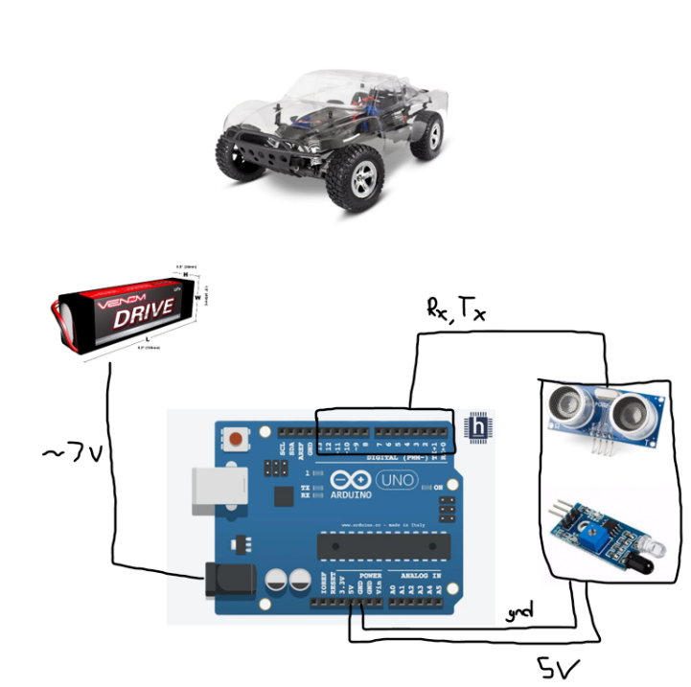

The Physical design of our project will be a “Hobby Level” Remote control Car with durable, multi-surface rubber wheels, transparent plastic frame and transparent plastic outer shell, and Standard RC batteries, remote, and other on-board electronics. In addition to the RC base, we will include an Arduino to control the on-board electronics based on input from several Infra-red and ultra-sonic sensors that will also be included in the on-board electronics. We will use embedded programming for all automation and programming for vehicle movement to ensure latency is kept to a minimum by removing any need for it to communicate with an off-board computer.

The Components of the Vehicle and their functionalities are as follows:

* Wheels/Car Body
  + - The larger and more durable wheel and body choice will allow the car to operate outdoors on rough terrain, on bumpy cement, etc. Which ensures that the vehicle will not be hindered by physical constrains on the ground.
    - We also will make modifications to the body of the vehicle to mount sensors. This will include creating holes or exterior mounts for the Ultra-Sonic sensors, because they cannot be fully encased by the transparent shell.
* Arduino
  + - The on-board Arduino (along with a breadboard) will act as the brain of the vehicle and will connect to all the sensors as well as motors to automate the vehicle's navigation. It also will have software written to prevent the various aspects of the design from being compromised by the hacking performed by the track team.
* Sensors (IR and US)
  + - We will use Ultra-sonic sensors as the main sensors to be used for object detection. The design will include 5 total US sensors placed around the edge of the car detection at different angles.
    - Depending on the layout, size, and other factors of the track, we will use the Infra-red sensors in one of two ways:
      * Facing the ground for border detection. This would be used if the track team chooses to use tape for the borders, because it would need to detect the borders that are flush to the ground.
      * Facing out to aid in accuracy of object/boarder detection. This would be used if the track team elected to use H-Vac tubing for the borders, because we would not need separate object and border detection so we would instead be able to refine the object detection.
* Remote Control
  + - The remote control will be operated during the Race to control the speed of the vehicle to help navigate its way through obstacles

## 4.8 Technology Considerations

Our weakness in this project was being bounded by our budget because there is a lot of technology that exists for this application. There is a sensor that we wanted to implement that would help with accuracy in the autonomy of the vehicle which is a Lidar sensor. A quality Lidar sensor was well beyond our budget, so we had to consider another option which is why we are using a combination of ultrasonic and infrared sensors which is much cheaper. The advantage we created is that we were able to invest more into our vehicle, so it should be durable, fast, and very reliable. Another helpful decision is that communication between the Arduino and speed controller of the vehicle will be a lot smoother since it is plug and play.

## 4.9 Design Analysis

For our current design we are still building the vehicle and performing more tests on all of the components. Once we have finished testing the components, we will continue to test the finished vehicle and see how well our design will fit the needs to the track. Our vehicle design is a flexible approach that should work with most environments. We took this approach because we do not know the final design of the track, only some pieces of it. Once we get closer to figuring out further needs for the design, we will implement them to allow the vehicle to be better suited for the track.

# 5 Testing

## 5.1 Unit Testing

LIPO Battery – Test the voltage output using a voltmeter. Making sure that the voltage matches the voltage that the products mentions it should produce.

IR sensor – Test the voltage using a voltmeter. Test the product while under load while connected to the battery. Test the value thresholds of the IR sensor using live data fed through the Arduino.

Ultrasound sensor – Test the voltage using a voltmeter. Test the sensor while under load while connected to the battery. Test the sensor range while monitoring the values using live data that will be fed through the Arduino using a tape measurer. See the width that the ultrasound sensor picks up by measuring the angle starting from the very center of where the sensor is facing using a protractor.

Arduino – Check each of the pins and make sure they are all functioning properly as intended from the factory. Then test the voltage supply where the sensors will be connected as well as the voltage under load while connected to the LIPO battery using a voltmeter.

RC Car Kit - Measure the RC car to make sure it conforms to the 1/10th scale using a tape measurer with the car fully assembled with all of the sensors attached. Test the speed of the car by measuring the maximum speed using a speedometer.

## 5.2 Interface Testing

Some of the interfaces of our design are the digital interface on the Arduino, the user input on the remote control, the data input with sensors, and the movement with motors.

There a several connected interfaces in our design. Many of them will revolve around the Arduino that controls the vehicle and acts as the “brain” of the car. A few examples are:

The Arduino and the Sensors, which we can test are interacting correctly by repeated testing where we know the expected result. Verifying that the data is being passed to the Arduino correctly and we are getting the expected value.

The remote control and the Arduino. Though the vehicle will navigate autonomously, we will be able to determine the speed by remote control. We will be able to test this by sending a signal to the Arduino that we know what it should receive, to verify it is getting passed by radio signal to the vehicle.

## 5.3 Integration Testing

The Arduino must supply enough voltage to the different sensors that will be connected to it. Also, the battery must supply enough voltage to the Arduino and the rest of the components of the RC car. We will measure the voltage output on the Arduino to ensure that it is correct. Additionally, the voltage output of the battery will be checked with a voltmeter to make sure that everything is in acceptable ranges when the battery is both full and close to empty.

## 5.4 System Testing

There are multiple implementations for the autonomous implementation of the RC car. We will run different tests in different areas first such as track edge detection, single object detection, etc... Then we will implement a test field that will run through all of the applications at once and see the interactions between each of the combined tests. During this process, we will measure the accuracy of the different tests and try to ensure that it’s within our required thresholds.

## 5.5 Regression Testing

New additions will be implemented one at a time. Previous functionalities that fulfill our requirements will be tested in case new additions break old functionalities. If the new addition introduces a new functionality, this will be tested as well. This will be repeated until the while system is implemented. All functionalities must be tested and checked off before new additions are implemented.

## 5.6 Acceptance Testing

Acceptance testing will be demonstrated through a physical demonstration of our project. There, the client will be able to fully assess the functionality of our project and see if they fit the requirements set out by the client. Documentation of other tests can also be used to demonstrate completion of design requirements.

## 5.7 Security Testing (if applicable)

In our design, we will test security by penetration testing our overall design to see what vulnerabilities we are able to discover and exploit. More specifically, we will attempt to create a breach of security in the passing of signals from the remote, attempt to tamper with the sensor data input, and try to find ways to physically disrupt the vehicle.

After doing penetration testing, we will document our findings and work to fix any holes/bugs in the security and remediate any vulnerabilities found during testing.

## Testing Results

Currently we have begun basic system testing. Primarily testing the capabilities of the base RC car, we will be using for our design. This process has thus far included testing acceleration, top speed, difficult terrain capabilities, and some basic durability testing. So far, we’ve found that the Top Speed the vehicle can reach is 21 mph. It was able to reach this speed in between approximately 2 and 3 seconds. This meant the car was able to reach max speed in approximately 6 meters. Our basic durability testing included intentional low-speed collisions to ensure our vehicle would be able to withstand some crashes during testing without additional modifications. These tests proved successful with the “hobby grade” RC car base being more than durable enough to withstand the need for our design and project plan.

# 6 Implementation

As of right now, we have assembled and tested the vehicle in the manual control configuration. The course of action for next semester is to test and mount the sensors onto the vehicle, then connect the systems we will use for the autonomous driving via a breadboard and an Arduino Uno. After that, we will be able to program the Arduino to run our autonomous vehicle code. At that point we will begin the testing and refinement process of the code to make sure that the system works as quickly and reliably as possible.

# 7 Professionalism

This discussion is with respect to the paper titled “Contextualizing Professionalism in Capstone Projects Using the IDEALS Professional Responsibility Assessment”, *International Journal of Engineering Education* Vol. 28, No. 2, pp. 416–424, 2012

## 7.1 Areas of Responsibility

|  |  |  |  |
| --- | --- | --- | --- |
| **Area of Responsibility** | **Definition** | **NSPE Canon** | **IEEE Canon** |
| Work Competence | Perform work of high quality, integrity, timeliness, and professional competence. | Perform services only in areas of their competence; Avoid deceptive acts. | Undertake work for others only if qualified by training or experience |
| Financial Responsibility | Deliver products and services of realizable value and at reasonable costs. | Act for each employer or client as faithful agents or trustees. | Avoid unlawful conduct and reject bribery |
| Communication Honesty | Report work truthfully, without deception, and understandable to stakeholders. | Issue public statements only in an objective and truthful manner; Avoid deceptive acts. | Be honest and realistic when making statements based on data |
| Health, Safety, Well-being | Minimize risks to safety, health, and well-being of stakeholders. | Hold paramount the safety, health, and welfare of the public. | Uphold the safety, health, and welfare of the public (Same as NSPE) |
| Property Ownership | Respect property, ideas, and information of clients and others. | Act for each employer or client as faithful agents or trustees. | To protect the privacy of others |
| Sustainability | Protect environment and natural resources locally and globally. |  | Disclose factors that may endanger the environment |
| Social Responsibility | Produce products and services that benefit society and communities. | Conduct themselves honorably, responsibly, ethically, and lawfully so as to enhance the honor, reputation, and usefulness of the profession. | Improve the understanding by individuals the capabilities of emerging technology |

## 

Figure 7.1 – Table outlining factors of engineering responsibility.

## 7.2 Project Specific Professional Responsibility Areas

Work Competence:   
In order to bring about a successful project, we need to be able to work at a high quality, otherwise we will not be able to build a robot that meets the requirements of our project. We will also need to work with timeliness, otherwise we will fall behind and not complete the robot by the deadline. For this area of responsibility, we are on schedule with the tasks we need to complete so we would score “high” in this area.

Financial Responsibility:

For this project, we are limited by a budget, so we will need to design a robot that meets all our requirements while staying within our budget. For this area of responsibility, we are well within our budget, utilizing only 3/5 of our current budget. For this area, we would score “high”.

Communication Honesty:

For this project, we are working together with a client and an advisor. It is important to relay honest information to both so that they understand the scope and current progress of our project and provide useful and insightful feedback for our group. For this area of responsibility, we have been doing as such, so we would score “high” in this area.

Health, Safety, Well-Being:

This project does not involve dangerous equipment nor does the project itself endanger others. It is still important to maintain basic safety standards when working inside the laboratory. For this area of responsibility, safety standards have been maintained, so we would score “high” in this area.

Property Ownership:

This project involves 2 other groups, another robot team and a track team. It is important to respect the piracy of all non-public information as to respect the ideas and work of other groups. For this area, we have respected the privacy of other groups, so we would score “high” in this area.

Sustainability:

This area of responsibility would not be applicable to our project, as the work we do does not directly affect the environment in a negative way.

Social Responsibility:

For this project, it is important to understand that the work we do can impact not just us but the school we represent. Therefore, we need to act responsibly and honorably so that we maintain the image of our professions and our school. For this area expertise, we have been doing as such, so we would score “high” in this area.

# 8 Closing Material

## 8.1 Discussion

Discuss the main results of your project – for a product discuss if the requirements are met, for experiments oriented project – what are the results of the experiment, if you were validating a hypothesis – did it work?

We are omitting this portion for the fall semester, as we are yet to implement our design.

## 8.2 Conclusion

Our goal this semester was to design an autonomous RC car that can avoid a variety of obstacles with a limited budget. This semester, we brainstormed potential obstacles that we may encounter and developed solutions, such as the implementation of IR and ultrasonic sensors to avoid roadblocks. Issues such as budget constraints prevented us from using powerful sensors such as a LIDAR and restricted us to a few options for sensors. We developed a list of parts needed for the operation of the vehicle and then constructed a basic working RC car at the end of this semester.

Moving forward, we will implement sensors onto the RC car and test the functionality with each addition. We will continue to test and improve our car's functionality until the end of spring semester so that it can overcome many obstacles developed by our track team.

## 8.3 References

List technical references and related work / market survey references. Do professional citation style (ex. IEEE).

We are omitting this portion for the fall semester, as we are yet to implement our design.

### 8.4.1 Team Contract

**Team Name** _____sdmay24-06__________________________

**Team Members:**

1) ______Ben Dubin_ _______________ 2) ___Aaron Gienger________________

3) _____ Andy Nguyen______________ 4) _______________________________

5) ______Blake Carlson_ ____________ 6) _______________________________

7) ______Carson Tow_ ______________ 8) _______________________________

**Team Procedures**

1. Day, time, and location (face-to-face or virtual) for regular team meetings:

Friday at noon (Hybrid)

1. Preferred method of communication updates, reminders, issues, and scheduling (e.g., e-mail, phone, app, face-to-face):

Discord and Github

1. Decision-making policy (e.g., consensus, majority vote):

Initial vote with an explanation to work towards a majority vote or consensus

1. Procedures for record keeping (i.e., who will keep meeting minutes, how will minutes be shared/archived):

Git and class documents

**Participation Expectations**

1. Expected individual attendance, punctuality, and participation at all team meetings:

Consistent attendance and keep up with communication if a conflict comes up

1. Expected level of responsibility for fulfilling team assignments, timelines, and deadlines:

Equal amount between the whole team

1. Expected level of communication with other team members:

Keep up with updates on all the platforms we use and keep it consistent

1. Expected level of commitment to team decisions and tasks:

Shoot for the deadlines and commit effort to team decision and tasks

**Leadership**

1. Leadership roles for each team member (e.g., team organization, client interaction, individual component design, testing, etc.):

Scrum master, Notetaker during meetings, Primary and secondary client communicator, Tech lead

1. Strategies for supporting and guiding the work of all team members:

Having someone setup tasks and soft deadlines

1. Strategies for recognizing the contributions of all team members:

Git and written timeline for different tasks

**Collaboration and Inclusion**

1. Describe the skills, expertise, and unique perspectives each team member brings to the team.

-Embedded hardware Programming (Blake Carlson, Aaron Gienger)

-Electrical hardware design (Andy Nguyen)

-Programming for remote control hardware (Carson Tow)

-Software development (Ben Dubin)

-Basic electrical work & soldering (Everyone)

1. Strategies for encouraging and support contributions and ideas from all team members:

Open to ideas and feedback and be open and flexible within the meetings

1. Procedures for identifying and resolving collaboration or inclusion issues (e.g., how will a team member inform the team that the team environment is obstructing their opportunity or ability to contribute?)

Identify different issues during the rundown of different tasks

**Goal-Setting, Planning, and Execution**

1. Team goals for this semester:

Put our best effort forward

Begin with a strong start for the senior design project

Get a working autonomous car

1. Strategies for planning and assigning individual and team work:

Scrum master will assign and set the work for the team

1. Strategies for keeping on task:

Open communication and bringing issues during meetings or through communication lines during the week

**Consequences for Not Adhering to Team Contract**

1. How will you handle infractions of any of the obligations of this team contract?

Discuss it as a team and try to resolve the problem

1. What will your team do if the infractions continue?

Bring in the TA

***************************************************************************

a) *I participated in formulating the standards, roles, and procedures as stated in this contract.*

b) *I understand that I am obligated to abide by these terms and conditions.*

c) *I understand that if I do not abide by these terms and conditions, I will suffer the*

*consequences as stated in this contract.*

1) Benjamin Dubin DATE 9/10/2023

2) Blake Carlson DATE 9/10/2023

3) Aaron Gienger DATE 9/10/2023

4) Andy Nguyen DATE 9/10/2023

5) Carson Tow DATE 9/10/2023

Works Cited

Gong, Steven. “Building the Fastest Self Driving RC Car.” *YouTube*, YouTube, 7 Apr. 2023, www.youtube.com/watch?v=R87Qlq_wSY8&t=0s.